Completing GT (Graduation Transitions) & Exit Interviews

**All grade 12 all students** are required to complete all sections of Graduation Transitions in order to earn 4 credits to graduate. Also, students will need to complete GT before buying their Grad Dinner and Dance tickets!

* Log into any computer at school, home, work to: **gleneagle.org**
* **select “Programs & Services”**
* **then “Grad Transitions**



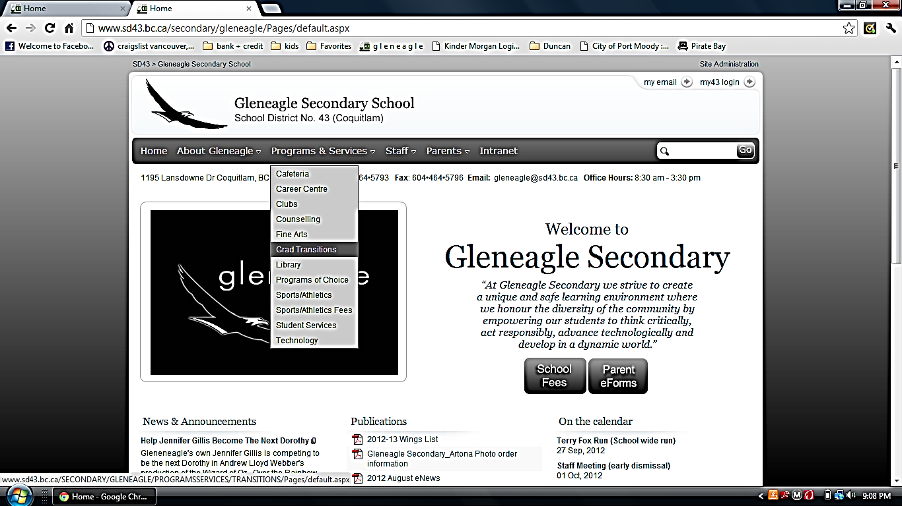

**Click on the “Grad Transition Completion” link ........... sign in with your school username and password and** **you’ll see the new GT website. Follow the instructions.**

**OR**

* Go to **gleneagle.org .** Click on **Intranet** and then **“gt-dpa”**. Log in with your school username and password.





* **You may have completed some assignments previously on the old site, such as the Healthy Living Plan in Planning 10 and DPA in grades 9, 10 & 11.**
* **You will be able to see your saved work.**
* **Follow the instructions given on the site. Complete ALL 6 sections.**
* **SAVE OFTEN! When you start working on GT (each time) test your connection by saving early on. Copy and save your work in Word or use the Word version of many of the assignments that is available on the GT main page.**

**\*\*\*\*\*\*\*The FINAL due date for GT is February 13th , 2015**

* **Email Ms. Horvath (jhorvath@sd43.bc.ca) if you have**

**any questions AND when you think you’re done.**



**Exit Interviews**

* **This is the culminating activity for GT. Your assignments should be complete before you do your Exit Interview as they will help you prepare for it.**
* **All info can be found on the GT site. Click on the “Exit Interviews” tab at the top of the opening page**
* **the Exit Interview date for all grade 12s will be April 23rd , 2015**

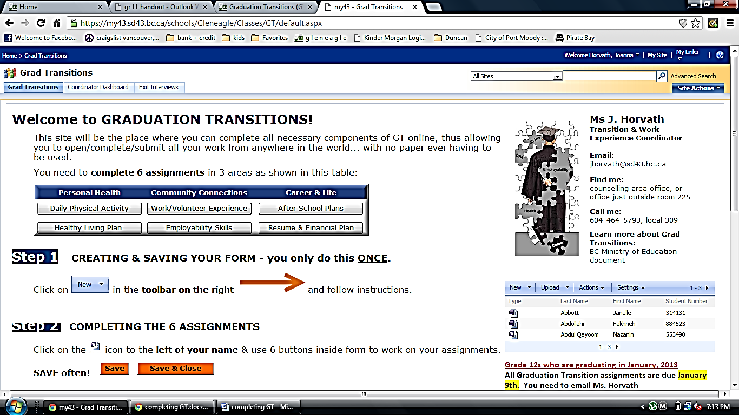

***\*\*\*you CAN and SHOULD aim to complete your GT assignments earlier than the due date. You may be able to book an earlier Exit Interview date if it’s early enough. Email Ms. Horvath.\*\*\****